import numpy as np

import pandas as pd

import matplotlib.pyplot as plt

from mpl_toolkits.mplot3d import Axes3D

from sklearn.preprocessing import StandardScaler

import seaborn as sns

from collections import Counter

nRowsRead = 200000

df = pd.read_csv("PDataset-Unicauca-Version2-87Atts.csv", delimiter=',', nrows = nRowsRead)

df.head()

**OUTPUT**

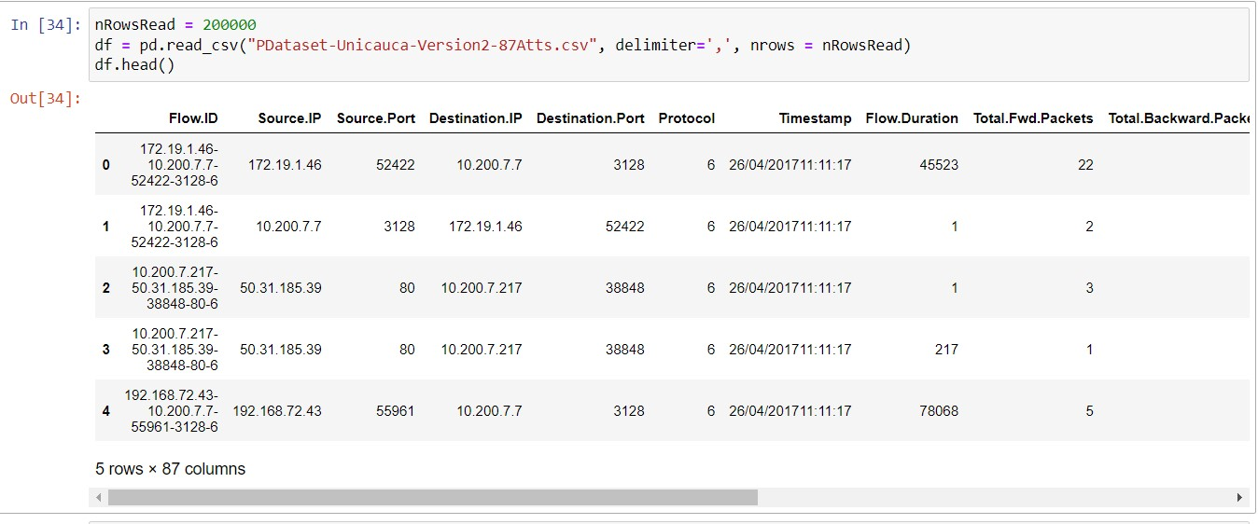

print(sorted(Counter(df['ProtocolName']).items()))

**output**



top =df['ProtocolName'].value_counts()

top.sort_values(ascending = False)

top = top[ : 6]

top.plot(kind = "bar")

**OUTPUT**

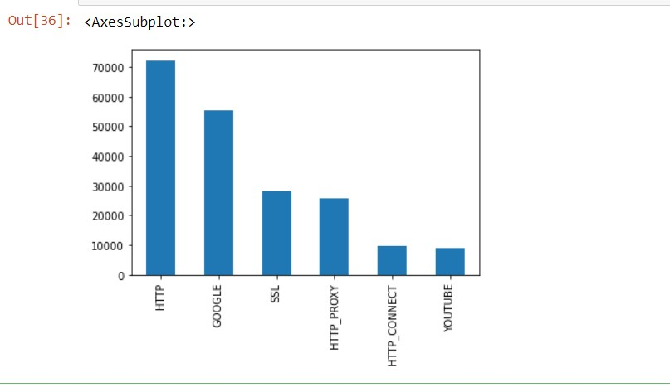

**UNDER SAMPLING**

X = df

Y = df['ProtocolName']

from imblearn.under_sampling import RandomUnderSampler

rus = RandomUnderSampler(random_state = 0)

X_resampled,y_resampled = rus.fit_resample(X, Y)

print(sorted(Counter(y_resampled).items()), y_resampled.shape)

**OUTPUT**



top = y_resampled.value_counts()

top.sort_values(ascending = False)

top = top[ : 6]

top.plot(kind = "bar")

**OUTPUT**

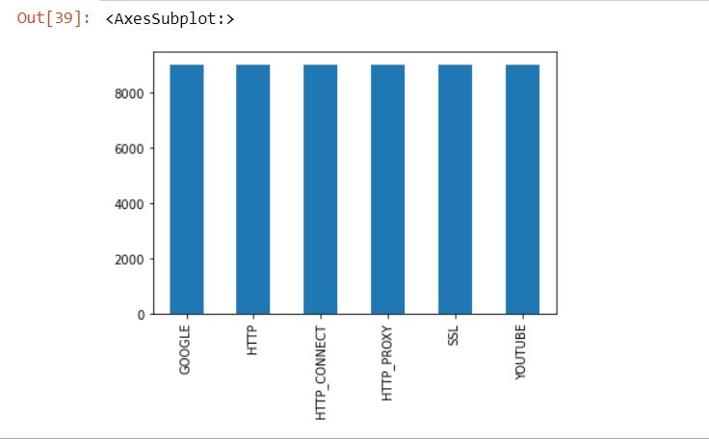

df.shape

**OUTPUT**



**DATA PREPROCESSING**

ipdata = df.copy()

print("No. of unique values in Timestamp column :",ipdata['Timestamp'].nunique())

print("No. of unique values in FlowID column :",ipdata['Flow.ID'].nunique())

**OUTPUT**

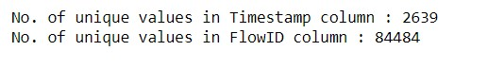

ipdata.drop(['Timestamp', 'Flow.ID'], axis = 1, inplace = True)

single_unique_cols = [col for col in ipdata.columns if ipdata[col].nunique() == 1]

single_unique_cols

**OUTPUT**

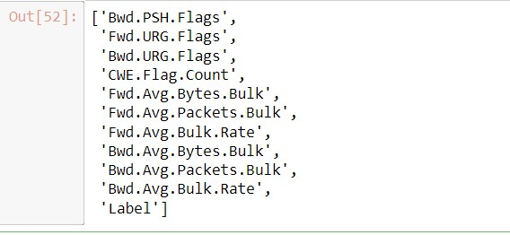

ipdata.drop(single_unique_cols, axis = 1, inplace = True)

ip_add_cols = ['Source.IP', 'Source.Port', 'Destination.IP', 'Destination.Port']

ipdata[ip_add_cols]

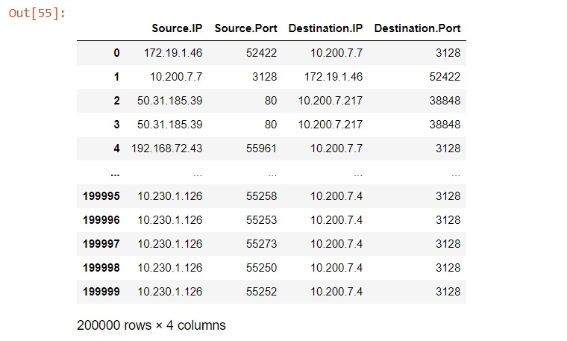

ipdata.drop(ip_add_cols, axis = 1, inplace = True)

from sklearn.preprocessing import LabelEncoder

encoder = LabelEncoder().fit(ipdata['ProtocolName'])

ipdata['ProtocolName'] = encoder.fit_transform(ipdata['ProtocolName'])

ipdata['ProtocolName']

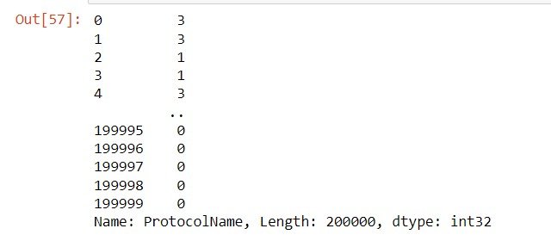

ipdata.head(10)

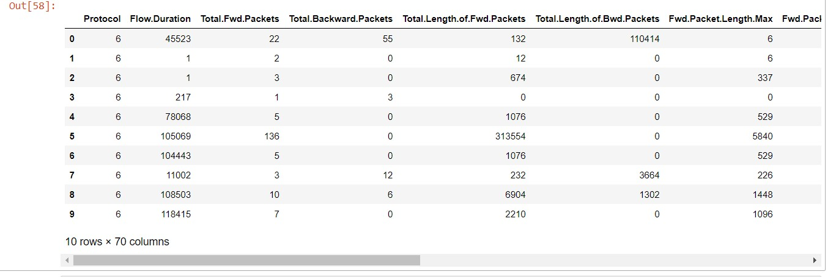

ipdata.shape



df1 = pd.Series(df['Flow.ID']).head()

df1

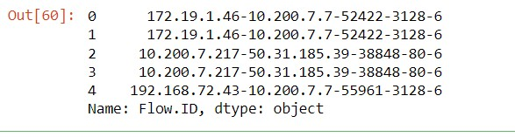

X1 = ipdata.iloc[:, : 69].values

Y1 = ipdata.iloc[: , 69].values

from sklearn.model_selection import train_test_split

X_train, X_test, y_train, y_test = train_test_split(X1, Y1, test_size = 0.2, random_state = 77)

print(f"rows in train set :{len(X_train)}\nrows in test:{len(X_test)}\n")

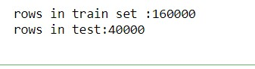

from sklearn.preprocessing import StandardScaler

sc = StandardScaler()

X_train = sc.fit_transform(X_train)

X_test = sc.transform(X_test)

**LOGISTIC REGRESSION**

from sklearn.linear_model import LogisticRegression

classifier = LogisticRegression(random_state = 0)

classifier.fit(X_train, y_train)

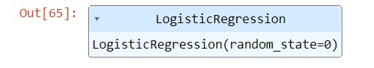

y_pred = classifier.predict(X_test)9

from sklearn.metrics import confusion_matrix, accuracy_score, classification_report

cm = confusion_matrix(y_test, y_pred)

print("confusion Matrix : \n", cm)

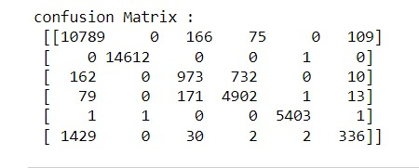

from sklearn.metrics import accuracy_score

print("Accuracy : ", accuracy_score( y_pred,y_test))

print(classification_report(y_test,y_pred))

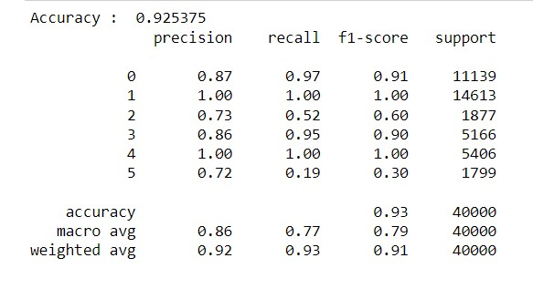

**SVM**

from sklearn.svm import SVC

classifier = SVC(kernel = 'linear', random_state = 0)

classifier.fit(X_train,y_train)

y_pred = classifier.predict(X_test)

from sklearn.metrics import accuracy_score

print("Accuracy : ", accuracy_score( y_pred,y_test))

print(classification_report(y_test,y_pred))

**RANDOM FOREST**

from sklearn.ensemble import RandomForestClassifier

classifier = RandomForestClassifier(n_estimators = 10, criterion= 'entropy', random_state= 0)

classifier.fit(X_train, y_train)



y_pred = classifier.predict(X_test)

from sklearn.metrics import confusion_matrix, accuracy_score, classification_report

cm = confusion_matrix(y_test, y_pred)

print("confusion Matrix : \n", cm)

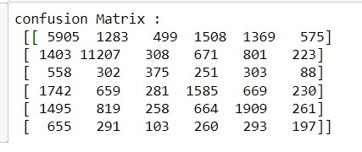

from sklearn.metrics import accuracy_score

print("Accuracy : ", accuracy_score( y_pred,y_test))

print(classification_report(y_test,y_pred))

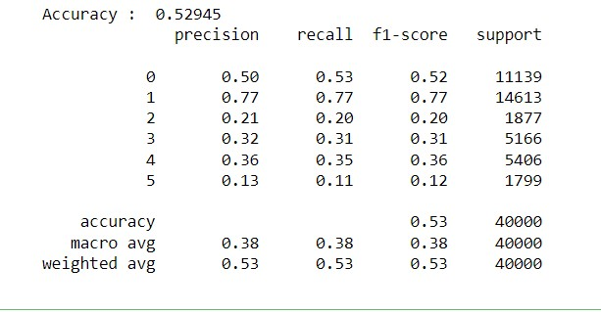

**# CROSS VALIDATION**

from sklearn.model_selection import cross_val_score

accuracies = cross_val_score (estimator = classifier, X = X_train, y = y_train, cv = 4)

print("Accuracy: {:.2f} %%".format(accuracies.mean()*100))

print("Standard Deviation: {:.2f} %%". format (accuracies.std ()*100))

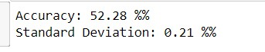

**K-NN**

from sklearn.decomposition import PCA

pca = PCA(n_components = 1 )

X_train = pca.fit_transform(X_train)

X_test = pca.transform(X_test)

from sklearn.neighbors import KNeighborsClassifier

classifier = KNeighborsClassifier(n_neighbors = 5, metric = 'minkowski', p = 2)

classifier.fit(X_train, y_train)

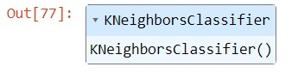

y_pred= classifier.predict(X_test)

cm=confusion_matrix(y_test,y_pred)

print("confusion Matrix : \n", cm)

from sklearn.metrics import accuracy_score

print("Accuracy : ", accuracy_score( y_pred,y_test))

print(classification_report(y_test,y_pred))

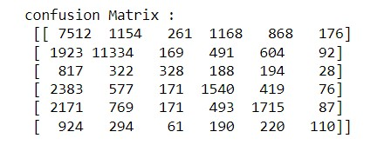

from sklearn.metrics import accuracy_score

print("Accuracy : ", accuracy_score( y_pred,y_test))

print(classification_report(y_test,y_pred))

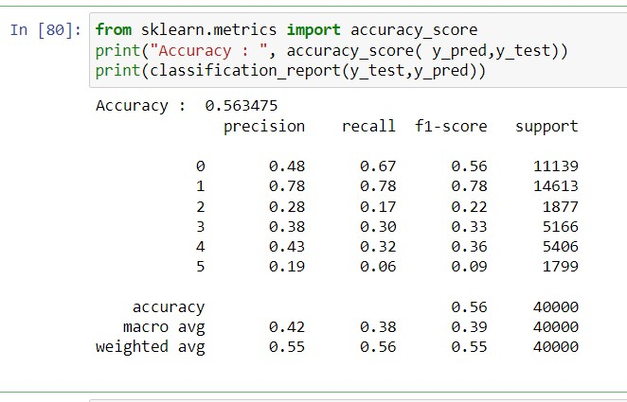

**# CROSS VALIDATION**

from sklearn.model_selection import cross_val_score

accuracies = cross_val_score (estimator = classifier, X = X_train, y = y_train, cv = 4)

print("Accuracy: {:.2f} %%".format(accuracies.mean()*100))

print("Standard Deviation: {:.2f} %%". format (accuracies.std ()*100))

